Task 4: AEM

News Page Component Implementation Creating News Page Component: News Page Component is created using the Base Page Component to maintain a consistency in structure and functionality across different pages.

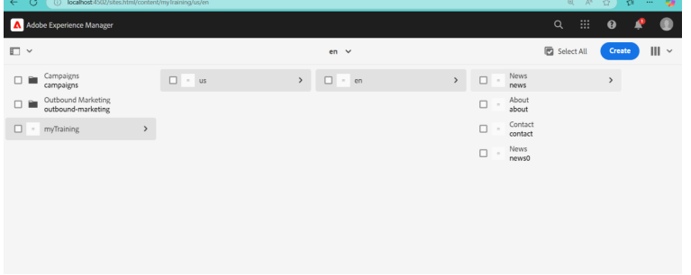

Custom Page Property: A custom page property called About is created. This allows content authors to set a default news image that will be displayed when no specific image is provided for a news article.

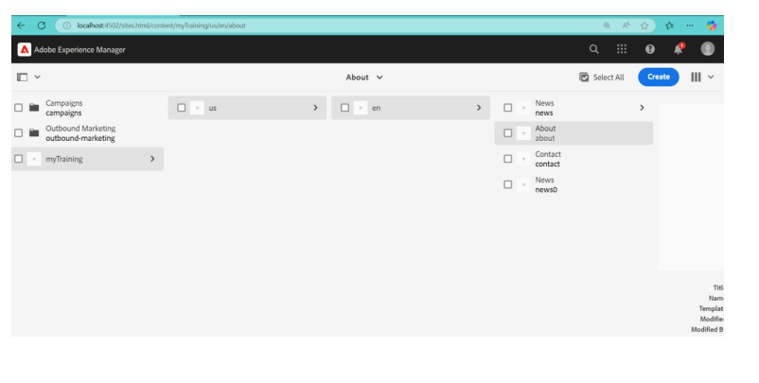

Creating News Template Type: A News Template Type is created using the News Page Component to standardize the layout and behavior of news pages.

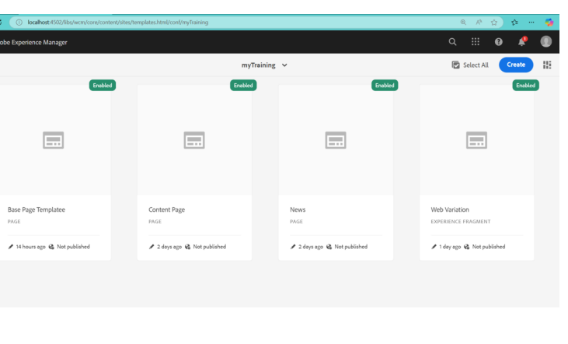

Applying Styling from ui.frontend Folder: The styling for the News Component and Hello World Component is applied from the ui.frontend folder to maintain consistency and a professional look.

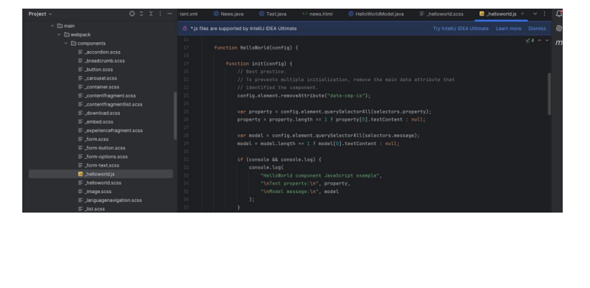

Creating Custom Style for News Component: A custom style is created to allow authors to apply specific styling to the Hello World and News Component, ensuring a consistent visual presentation.

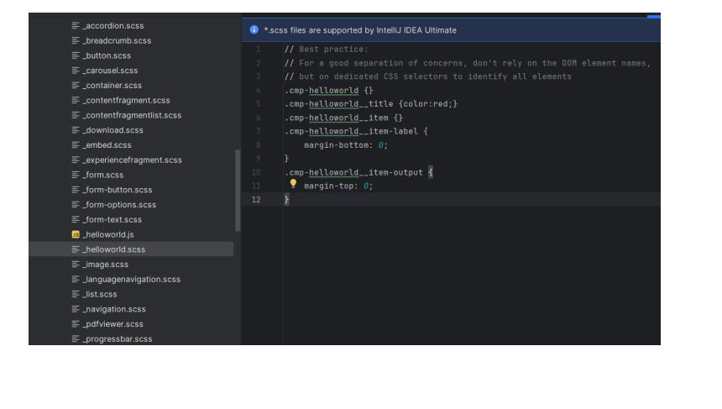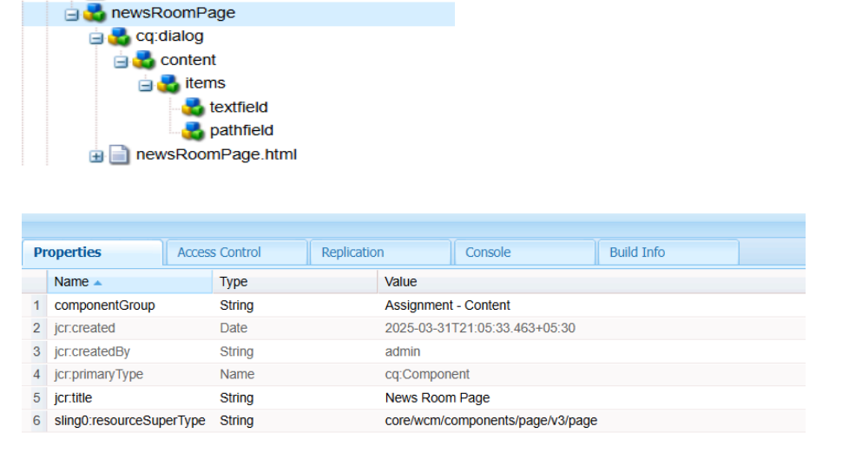2. Create custom page property as NEWS configurations where I can author the

default news image. Read More CTA for News Article

**Location:**

/apps/assignment/components/page/newsRoomPage/_cq_dialog.xml

**Code:**

xml

CopyEdit

<jcr:root xmlns:sling="http://www.sling.apache.org/jcr/sling/1.0"

xmlns:cq="http://www.day.com/jcr/cq/1.0"

jcr:primaryType="nt:unstructured"

sling:resourceType="cq/gui/components/authoring/dialog"

cq:dialogMode="floating">

<content jcr:primaryType="nt:unstructured">

<items jcr:primaryType="nt:unstructured"

<!-- Read More CTA Field -->

<textfield

jcr:primaryType="nt:unstructured"

sling:resourceType="granite/ui/components/coral/foundation/form/textfield"

fieldLabel="Read More CTA"

name="./readMoreCTA"/>

<!-- Default News Image Path Field -->

<pathfield

jcr:primaryType="nt:unstructured"

sling:resourceType="granite/ui/components/coral/foundation/form/pathfield"

fieldLabel="Default News Image"

name="./defaultNewsImage"/>

</items>

</content>

</jcr:root>

 

**Read More CTA** → Text field where authors enter the button text.

 

**Default News Image** → Path field to select an image from **DAM**.

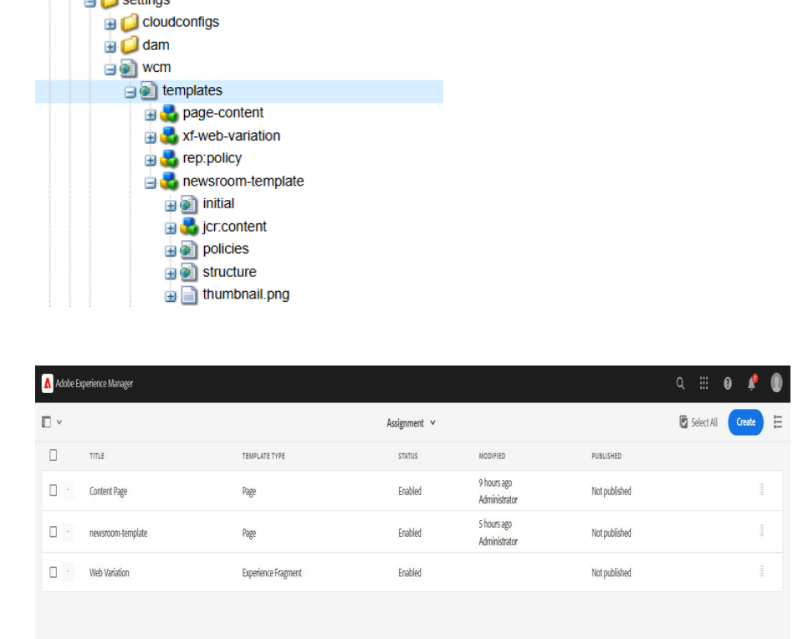 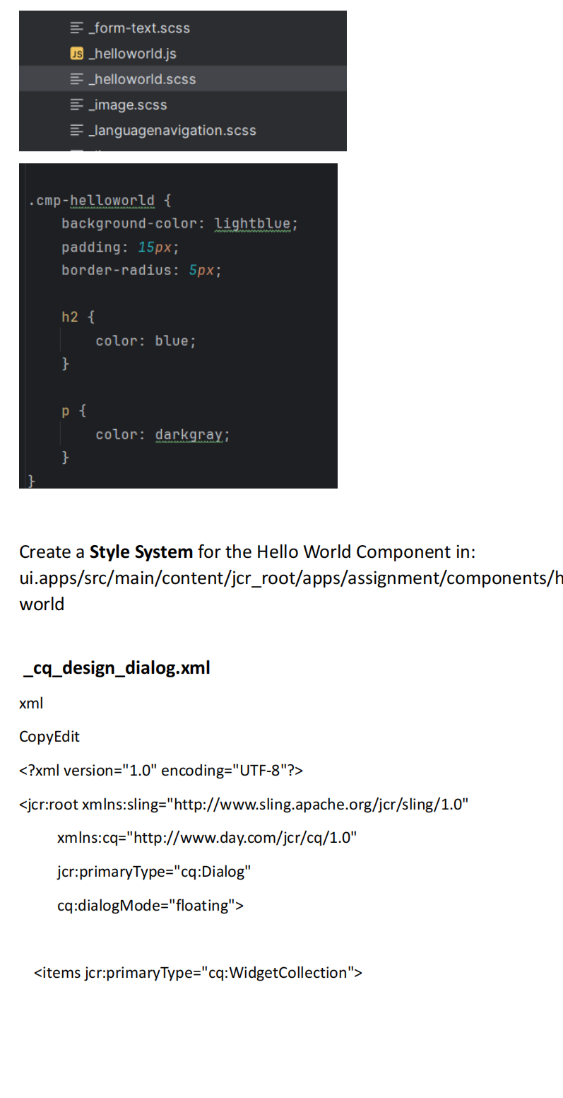 <styles jcr:primaryType="cq:Widget"

fieldLabel="Styles"

xtype="selection"

type="select"

items="[{'value':'custom-style-1','text':'Style 1'},{'value':'custom-style-

2','text':'Style 2'}]"/>

</items>

</jcr:root>